

Khwaja Yunus Ali University

***Lab Report -08***

**Name of the Department: Computer Science and Engineering**

**Course Code:** CSE 0713-1104

**Course Title:** Electrical Circuit Lab

**Experiment No.:** 08

**Name of the Experiment :** Study of Resonance behavior of a series of RLC circuits with variable Capacitance.

**Date of Experiment :** 06-04-2025

**Date of Submission :** 13-04-2025

**Instructor Signature & Date**

|  |  |  |
| --- | --- | --- |
| **Submitted by –** |  | **Submitted to –** |

**Name: Md Sojib Ahmed**

ID Number: 06224205101006

Batch No: 18th

Semester: 1st Year 2nd Semester

Khwaja Yunus Ali University

**Name: Sakil Ahammed**

Lecturer

Department of EEE

Khwaja Yunus Ali University

**Name of the Experiment:**

**Measurement of Power and Power Factor using AC Circuit**

**Objectives:**

* To measure power and power factor in a series RLC circuit using simulation.
* To understand the phase relationship between voltage and current.

**Theory:**

In AC circuits, power can be classified into three types:

* **Real Power (P):** The actual power consumed (in Watts).
* **Apparent Power (S):** The product of RMS voltage and current (in Volt-Amperes).
* **Power Factor (pf):** The ratio of real power to apparent power, given by:

$$\text{ Power Factor }=cos⁡θ=\frac{P}{S}$$

For sinusoidal signals:

$$V_{rms}=\frac{V_{m}}{\sqrt{2}}, I_{rms}=\frac{I_{m}}{\sqrt{2}}$$

Power factor indicates whether the circuit is resistive, inductive, or capacitive in nature.

**Circuit Diagram:**

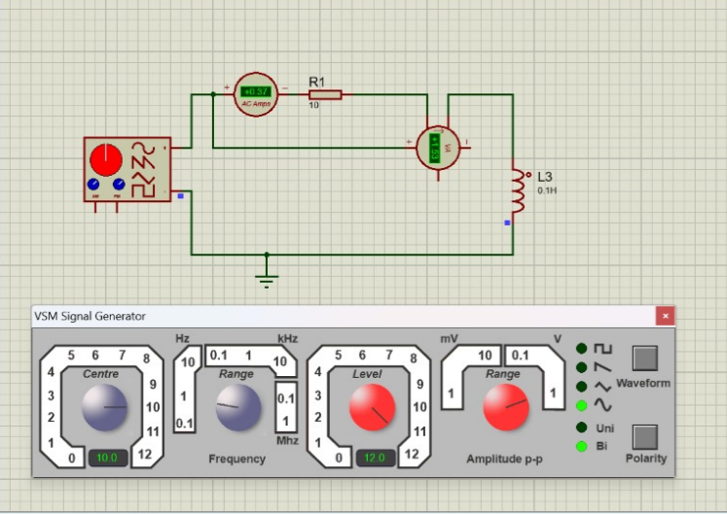

Fig. (1) AC Circuit for Power and Power Factor Measurement

### ****Apparatus Used:****

* AC Signal Generator
* Ammeter
* Voltmeter
* Resistor (R = 10Ω)
* Inductor (L = 0.1H)
* Proteus 8 Professional Software
* Connecting Wires

### ****Working Procedure:****

1. Opened Proteus 8 and constructed the circuit as shown.
2. Connected the ammeter in series and voltmeter in parallel with the load.
3. Used a VSM Signal Generator to supply AC voltage.
4. Measured the RMS current and peak voltage.
5. Calculated the real and apparent power.
6. Computed the power factor using the given formula.

### ****Given Data:****

* Peak Voltage, $V_{m}=52 V$
* Current, $I=0.37$ A
* Real Power, $P=3.53 W$

**Calculation:**

Apparent Power (S):

$$\begin{matrix}V_{rms}=\frac{V_{m}}{\sqrt{2}}=\frac{52}{1.414}=36.77 V \\ S=V_{rms}×I=36.77×0.37=13.6VA\end{matrix}$$

Power Factor (pf):

$$cos⁡θ=\frac{P}{S}=\frac{3.53}{13.6}≈0.26$$

| **SL No.** | **Peak Voltage (V)** | **RMS Voltage (V)** | **Current (A)** | **Apparent Power (VA)** | **Real Power (W)** | **Power Factor** |
| --- | --- | --- | --- | --- | --- | --- |
| 1 | 52 | 36.77 | 0.37 | 13.60 | 3.53 | 0.26 |
| 2 | 48 | 33.94 | 0.35 | 11.88 | 3.10 | 0.26 |
| 3 | 44 | 31.11 | 0.33 | 10.27 | 2.80 | 0.27 |
| 4 | 40 | 28.28 | 0.30 | 8.48 | 2.30 | 0.27 |

### ****Result and Discussion:****

* The apparent power was calculated to be **13.6 VA**, and the real power measured was **3.53 W**.
* This resulted in a **power factor of 0.26**, indicating a predominantly inductive circuit.
* The simulation verified the effect of phase difference between voltage and current on power factor.
* A low power factor suggests inefficiency due to reactive components.

### ****Conclusion:****

In this experiment, we successfully measured real and apparent power and determined the power factor of a series RLC circuit. The observed low power factor demonstrates the influence of inductive reactance, validating the concept of reactive power in AC circuits.